SIMATS ENGINEERING
ASSESSMENT TOOL 3 – Assignment 2

COURSE NAME: STATISTICS WITH R PROGRAMMING COURSE CODE: ITA04

COURSE OUTCOME COVERED

CO3: Construct and manipulate data frames using reshaping, merging, and file I/O operations in R to prepare structured datasets for analysis.. (BL3, BL5)

Assessment Tool Weightage: 20%

QUESTIONS: 5 Total Marks: 100

Annexure

Assignment 2

Code of Conduct:

I BIJOY VARGHESE (192411013) (Name / Reg No) certify that this submission is my original work and that I have adhered to the guidelines specified for this assessment.
I understand that any violation of academic integrity rules will result in disciplinary action.

Signature of the student:
BIJOY VARGHESE

Assignment 2:
- Generate 5 Questions for your Capstone Project module
- Apply the formulae and use the relevant graph to visualize it
- Upload the file in Github link
- Save the 5 Questions and Gihub link in the Excell sheet

PROJECT TITLE : Design and Implementation of a Rule-Based Fake News Identification System Using R
MODULE : 1
Data Collection and Preprocessing

QUESTION 1 :
Is there a significant difference between the mean word counts of news articles before and after preprocessing?
ANSWER :
CODE:
test1 <- t.test(data$words_before,
data$words_after,
paired = TRUE)

print(test1)
Formula Used:
t = d_mean / (s_d / sqrt(n))
Where:
- d_mean = mean of the paired differences
- s_d = standard deviation of the differences
- n = number of news articles
Graph: Box plot — Word Counts Before and After Cleaning.
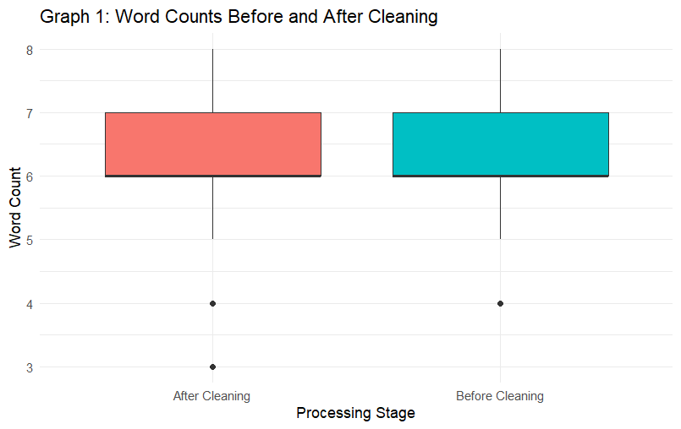

QUESTION 2 :
Is there a significant difference in mean word counts among Politics, Health, and Education news articles?

ANSWER:

CODE:
category <- c("Politics", "Politics", "Health",
"Health", "Education", "Education")
words <- c(20, 25, 30, 35, 22, 28)
data <- data.frame(category, words)
data$category <- as.factor(data$category)
print(data)
test <- aov(words ~ category, data = data)
print(summary(test))
boxplot(words ~ category, data = data,
main = "Word Count by Category",
xlab = "Category", ylab = "Word Count",
col = c("skyblue", "pink", "lightgreen"))
Formula:
F = Mean Square Between Groups / Mean Square Within Groups
Output:
Displays ANOVA results and a box plot.

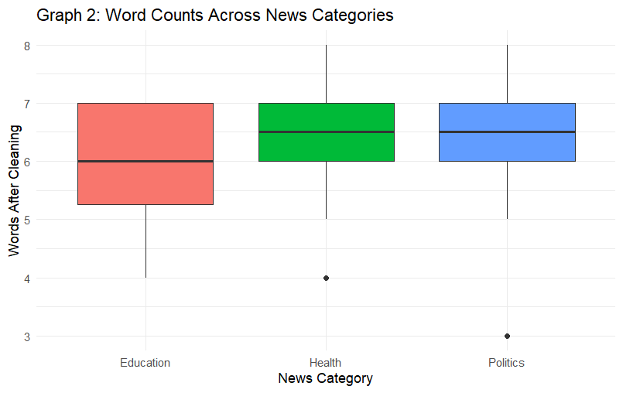

QUESTION 3 :
Is there an association between the article label (REAL/FAKE) and the presence of sensational words?

ANSWER :
CODE:

label <- c("REAL", "FAKE", "REAL", "FAKE",
"REAL", "FAKE", "REAL", "FAKE")
sensational <- c("No", "Yes", "No", "Yes",
"Yes", "Yes", "No", "No")
data <- data.frame(label, sensational)
tab <- table(data$label, data$sensational)
print(tab)
test <- chisq.test(tab, correct = FALSE)
print(test)
barplot(tab, beside = TRUE,
main = "Label vs Sensational Words",
xlab = "News Label", ylab = "Frequency",
col = c("skyblue", "orange"))
Formula:
χ² = Σ (Observed − Expected)² / Expected
Output:
Displays the contingency table, test results, and bar chart.
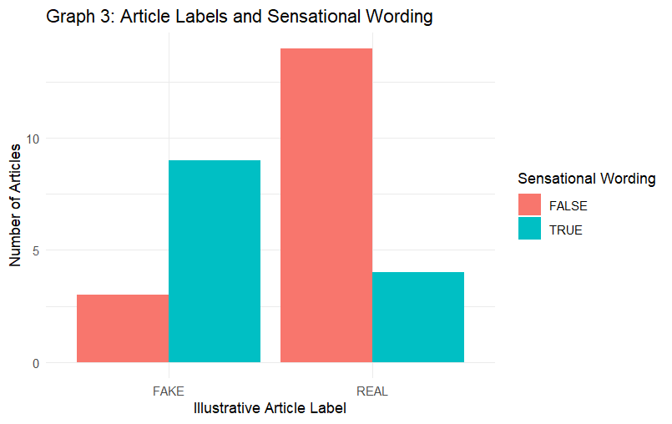

QUESTION 4 :
Is there a relationship between word counts before and after preprocessing?
ANSWER:

CODE:
before <- c(20, 25, 30, 35, 40, 45)
after <- c(18, 23, 27, 32, 36, 41)
data <- data.frame(before, after)
print(data)
test <- cor.test(before, after,
method = "pearson")
print(test)
plot(before, after,
main = "Before vs After Word Counts",
xlab = "Before Preprocessing",
ylab = "After Preprocessing",
pch = 19, col = "blue")
abline(lm(after ~ before), col = "red")

Formula:
r = Cov(X,Y) / (SD(X) × SD(Y))
Output: Displays the correlation coefficient, p-value, and scatter plot.
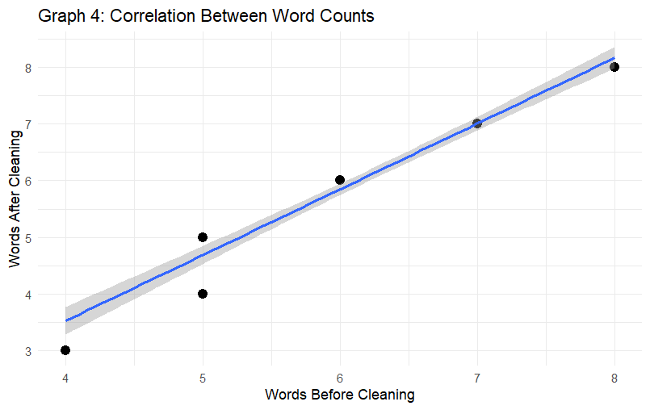

QUESTION 5 :
Are the word-count differences normally distributed?
ANSWER :

CODE:
difference <- c(2, 3, 4, 2, 5, 3, 4, 6)
print(difference)
test <- shapiro.test(difference)
print(test)
hist(difference,
main = "Distribution of Differences",
xlab = "Word Count Difference",
col = "lightblue")
qqnorm(difference,
main = "Normal Q-Q Plot")
qqline(difference, col = "red")
mean_value <- mean(difference)
sd_value <- sd(difference)
print(mean_value)
print(sd_value)
Formula:
W = [Σ aᵢx₍ᵢ₎]² / Σ(xᵢ − x̄)²
Output: Displays the Shapiro-Wilk results, histogram, Q-Q plot, mean, and standard deviation.

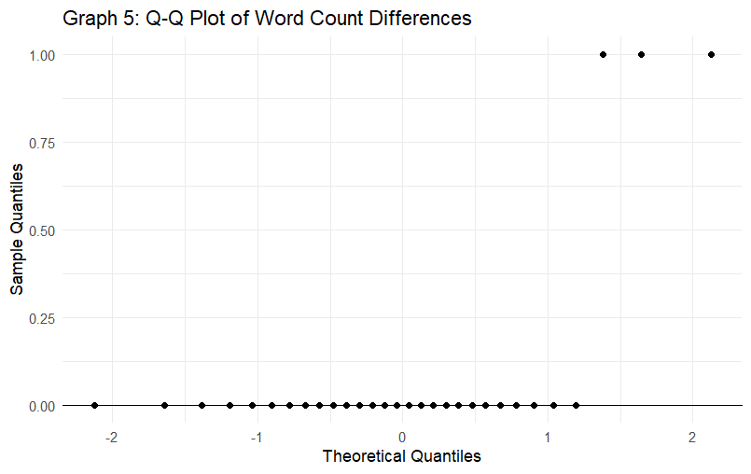

MODULE 1 IMPLEMENTATION :
